port industrial automation GmbH / Regensburger Strasse 7b / 06132 Halle-Saale / Germany
Tel: +49(0)345-77755-0
Fax: +49(0)34577755-20
Email: service@port.de
Responsible: Dietmar R. Franke (CEO)

Press Release

The Tool ICC (Industrial Communication Creator) by port – industrial automation GmbH supports Renesas’ RJ45 Multi Protocol Module (R-IN32M3 Module w/ Multi-Protocol Support) for PROFINET, EtherNet/IP and EtherCAT

Renesas offers module solutions for quick and reliable access to Industrial Real-Time Communication. These modules support PROFINET CC-B (incl. MRP), EtherNet/IP (incl. DLR) and EtherCAT. The ICC Engineering Tool supports the customer configurimg the module and establishing the communication.

The RENESAS industrial RJ45 Ethernet-Module (R-IN32M3-Module) is a certified hardware- and software solution, to speed up the development and offers a fast and price-effective access to the Industrial Ethernet market. One (1) hardware covers the 3 most important Industrial Ethernet Fieldbus protocols. Based on the technology of Renesas and Renesas’ quality standards offer this module certified software of the leading Industrial Ethernet-Protocols PROFINET® + MRP, EtherCAT® and EtherNet/IP ™ +DLR on board. The mechanical dimension is of the same size as a dual port RJ45 block would be. Upon Design-In standard cut-outs and housing can be used, alternatively upon re-designing products this module is mechanically (front cut-out) a drop-in replacement. The built-in PHYs and the simple Footprint enables for an easy design-in. A SPI connection hooks the module up the customer’s so called host CPU. Accordingly, existing host CPUs - though not as performant as today’s CPUs - can be maintained and used with PROFINET, EtherNet/IP and EtherCAT
The up-front investment for protocol stack licenses, implementation effort and certification cost can be significantly reduced.
Whether 5 or 500 units per year- RENESAS’ industrial RJ45 Ethernet-Module (R-IN32M3-Module) offers easy access to the Industrial Real Time Ethernet market.
port GmbH offers for the RENESAS Industrial RJ45 Ethernet-Module (R-IN32M3-Module) an Engineering Tool „ICC“ (industrial Communication Creator) - a unique and uniform tool to configure not only the objects dictionally of the module. Only one tool (uniform) allows to configure the „on board“ available protocols PROFINET, EtherNet/IP and EtherCAT. Besides the settings for the Resource Management, the Device Description, the settings of module and slot parameters, the Driver Settings and the Parameters/Assemblies/Connections the tools as well creates the GSDML (PROFINET), EDS (EtherNet/IP), ESI (EtherCAT) Files – this is unique functionality. The tool is available for Linux and Windows.
Port's ICC Tool offers beside comfort and ease-of-use another option to accelerate the development. On top this tool allows for a quality improvement as it reduces manual changes in the source code to a minimum. Individual errors by the operator are eliminated. The tool has an extra companion tool running command-line based and can so embedded into automated build systems.
A test version is available at port.de
about port GmbH
port is a leading supplier of industrial real time communication technologies like CANopen and Industrial Ethernet including the PROFINET, EtherNet/IP, EtherCAT POWERLINK, CC-LinkIE TSN, and TSN protocols. port GmbH has been located in Halle/Saale since 1990. port GmbH offers stacks, tools, workshops and integration support as well as custom hardware and software development, including manufacturing of electronic devices and systems.
Keywords:
PROFINET, MRP, EtherNetIP, DLR, EtherCAT, R-IN32M3 Module for Multi-Protocol Support, RIN32M3, Multi Ring Protokoll, Device Level Ring, RJ45 Module, embedded Profinet Module, embedded EtherNetIP Module, embedded EtherCAT Module, Real Time Communication over SPI, Real Time Kommunikation, industrial Ethernet, GSDML, ESI, ESD , RENESAS, RENESAS RIN32M3

Links: RENESAS Module https://www.renesas.com/eu/en/products/interface-connectivity/industrial-ethernet/multiprotocol-communication/r-in32m3-industrial-ethernet-module-certified-multiprotocol-industrial-ethernet-solution-profinet-and-ethernetip
ICC Tool - https://www.port.de/en/products/profinet/tools.html
ICC Tool Download Windows: https://www.port.de/en/download.html?tx_nbdownload_pi1%5Bfile%5D=L2ZpbGVhZG1pbi91c2VyX3VwbG9hZC9Qcm9kdWt0ZS9EZXNpZ25fVG9vbHNfbmV1L0Rlc2lnbl9Ub29sLzAyMTJfMTBfaWNjXzY0X3YwNC4wNi4wMC5leGU%3D
ICC Tool Download Linux: https://www.port.de/en/download.html?tx_nbdownload_pi1%5Bfile%5D=L2ZpbGVhZG1pbi91c2VyX3VwbG9hZC9Qcm9kdWt0ZS9EZXNpZ25fVG9vbHNfbmV1L0Rlc2lnbl9Ub29sLzAyMTJfMjBfaWNjXzY0X3YwNC4wNi4wMC50Z3o%3D
ICC Tool Manual (en): https://www.port.de/en/download.html?tx_nbdownload_pi1%5Bfile%5D=L2ZpbGVhZG1pbi91c2VyX3VwbG9hZC9Qcm9kdWt0ZS9EZXNpZ25fVG9vbHNfbmV1L0Rlc2lnbl9Ub29sL0lDQ19uZXh0R2VuX3VzZXJfTWFudWFsX1YwNF8wNl8wMC5wZGY%3D
Pictures:
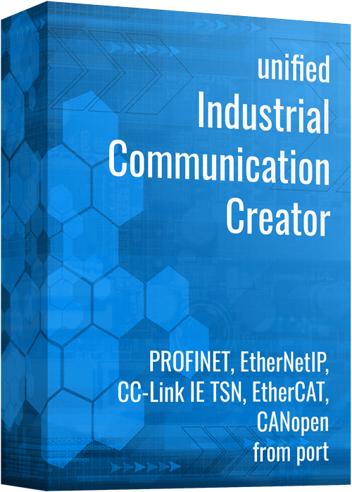
Abbildung 3 - ICC Multiprotokoll Tool 1
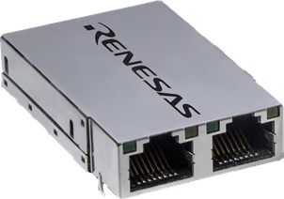
Abbildung 2 - RENESAS RJ45 Module**

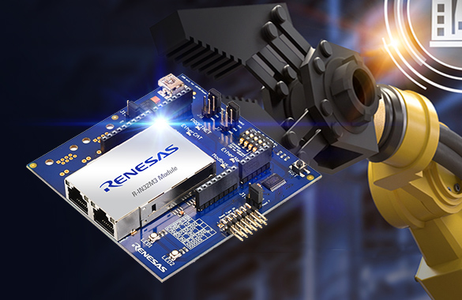
Abbildung 3 - RENESAS RJ45 Module auf Arduino Plattform**
** mit freundlicher Genehmigungdurch RENESAS

